How to spawn objects at random points within your game.

This will allow certain objects to spawn within an array of random spawn points.

1. Create a new Scene

Create a new scene and called “RandomSpawner”.

Make sure you set your camera to “2D”.

Add a 3D cube and name it “PickUp” and make a Prefab of this.

1. Creating Spawn Points

Create an “Empty GameObject” and rename it to “ItemSpawn”.

Then make 8 more “Empty GameObject” but as “Child Objects” and name them “SpawnPoint01”, “SpawnPoint02”, “SpawnPoint03”, ect...

Place your new “SpawnPoints” around the Scene anywhere.

1. Create A Script

Create a new Script and call it “SpawnItems”.

Place the Script on the “ItemSpawn” GameObject.

Within the Script, a “Transform” variable which we need to make into an Array, so we need to add “[ ]” to make one. We also need an “GameObject” Variable, follow the code below:

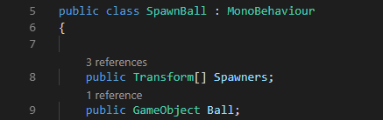

Now we need to set a “SpawnIndex” so we can “Instantiate” our “PickUp” from one of our spawn points.

Input the following code:

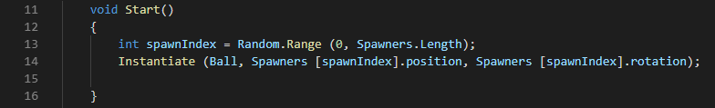

We placed our code in the “Start” function so everytime we run the game, our “PickUp” will be in at a different spawn point.

Before we start, save the script and go back to Unity.

1. Setting Up the Array

Go to our “ItemSpawn” GameObject and now we should see 2 new things within the Script Component. One being a drop down labelled “Spawners” and a GameObject named “Ball” (Yes, I know it’s a Cube).

Click on the drop down arrow next to “Spawners” and inside “Size” type the number “8”.

Now we should have Elements 0 to 7, Drag each spawn point into a free slot.

Drag the Prefab of our “PickUp” into the “Ball” slot.

Now Run the Game, it should work.